**Supplementary material for**

**Chicken colour discrimination depends on background colour**

by

Peter Olsson, Robin D. Johnsson, James J. Foster, John D. Kirwan, Olle Lind and Almut Kelber

**Content**

**1. Supplementary tables 3-11 with output from model selection model (i), ML GLM**

**2. Supplementary figures**

**All stimulus and background colour spectra are given in the supplementary file Olsson_et_al_stimuli_ and_background_spectra.xlsx.**

**1. Supplementary tables**

**Table S1.** Output from the *summary* command of the model in Table 1, chickens discriminating green colours, ML GLM, Model (i)

|  |  |  |  |  |
| --- | --- | --- | --- | --- |
|  | Estimate | Std. Error | Z value | Pr(>|z|) |
| (Intercept) | 3.49911 | 5.19403 | -1.870 | 0.06153 |
| Colour.difference | 3.49911 | 0.79934 | 4.378 | 1.2e-05 *** |
| backgroundorange | -0.07501 | 0.97494 | -0.077 | 0.93867 |
| sexmale | 7.45018 | 5.13468 | 1.451 | 0.14679 |
| indaB3 | 1.33703 | 0.66769 | -2.002 | 0.04524 * |
| indaB4 | 7.51505 | 5.23212 | 1.436 | 0.15091 |
| indaB5 | 7.51427 | 5.23073 | 1.437 | 0.15084 |
| indbB22 | -1.19186 | 0.64702 | -1.842 | 0.06546 |
| indbB32 | 6.00180 | 5.26890 | 1.139 | 0.25466 |
| indbB42 | 6.74312 | 5.25353 | 1.284 | 0.19930 |
| indbB62 | 6.90685 | 5.24983 | 1.316 | 0.18830 |
| indcB1 | 0.01252 | 0.43844 | 0.029 | 0.97721 |
| indcB2 | 5.18693 | 2.70491 | 1.918 | 0.05516 |
| indcB3 | 0.65855 | 0.45480 | 1.448 | 0.14762 |
| indcB6 | 1.63049 | 0.49729 | 3.279 | 0.00104 ** |
| inddB12 | 5.06975 | 2.68006 | 1.892 | 0.05854 |
| inddB22 | 2.56079 | 2.80216 | 0.914 | 0.36079 |
| inddB4 | NA | NA | NA | NA |
| inddB5 | NA | NA | NA | NA |
| batchb | NA | NA | NA | NA |
| batchc | NA | NA | NA | NA |
| batchd | NA | NA | NA | NA |
| Colour.difference:backgroundorange | 2.03505 | 2.93657 | 0.693 | 0.48831 |
| Colour.difference:sexmale | 0.59364 | 1.47558 | 0.402 | 0.68746 |
| backgroundorange:sexmale | NA | NA | NA | NA |
| Colour.difference:backgroundorange:sexmale | -4.58631 | 3.20169 | -1.432 | 0.15201 |

**Table S2.** Output from the *summary* command of the model in Table 1, chickens discriminating orange colours, ML GLM, Model (i)

|  |  |  |  |  |
| --- | --- | --- | --- | --- |
| **Variable** | **Estimate** | **Std. Error** | **Z value** | **Pr(>|z|)** |
| (Intercept) | -2.68655 | 0.62949 | -4.268 | 1.97e-05 *** |
| Colour.difference | 1.01745 | 0.20957 | 4.855 | 1.20e-06 *** |
| backgroundorange | -2.57941 | 2.01406 | -1.281 | 0.200298 |
| Sex male | 0.32566 | 0.56998 | 0.571 | 0.567764 |
| indaA3 | -0.08825 | 0.65139 | -0.135 | 0.892237 |
| indaA4 | 1.66617 | 2.16966 | 0.768 | 0.442523 |
| indaA5 | 0.05453 | 2.27462 | 0.024 | 0.980875 |
| indbA12 | -0.22904 | 0.69073 | -0.332 | 0.740198 |
| indbA2 | 0.37541 | 0.58858 | 0.638 | 0.523591 |
| indbA52 | -0.28523 | 2.30062 | -0.124 | 0.901331 |
| indbA6 | 0.16995 | 2.25051 | 0.076 | 0.939802 |
| indcA1 | 0.60371 | 0.38338 | 1.575 | 0.115325 |
| indcA3 | 0.75754 | 0.57497 | 1.318 | 0.187665 |
| indcA4 | 0.64820 | 0.38423 | 1.687 | 0.091599 |
| indcA5 | 0.95560 | 0.56156 | 1.702 | 0.088814 |
| inddA22 | 2.08880 | 0.61846 | 3.377 | 0.000732 *** |
| inddA32 | 0.76536 | 0.61425 | 1.246 | 0.212761 |
| inddA42 | 1.18315 | 0.60355 | 1.960 | 0.049959 * |
| inddA52 | NA | NA | NA | NA |
| batchb | NA | NA | NA | NA |
| batchc | NA | NA | NA | NA |
| batchd | NA | NA | NA | NA |
| Colour.difference:backgroundorange | 3.78159 | 1.86150 | 2.031 | 0.042207 * |
| Colour.difference:sexmale | 0.10775 | 0.35619 | 0.303 | 0.762257 |
| backgroundorange:sexmale | NA | NA | NA | NA |
| Colour.difference:backgroundorange:sexmale | -0.26714 | 2.12590 | -0.126 | 0.900002 |

**4. Supplementary figures**

**Figure S1. The experimental arena** as seen from above (left) and from the side (right), with the green background and orange stimuli.

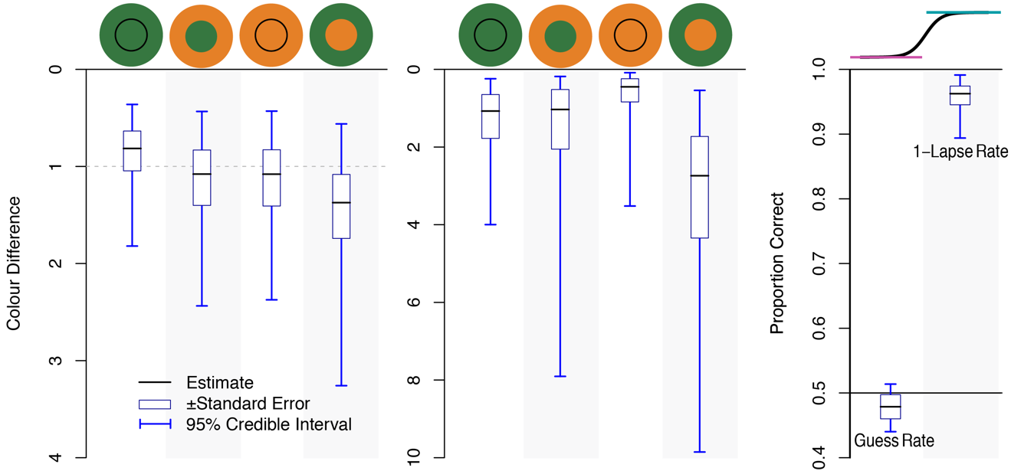

**Figure S2. Summary of posterior distributions for the threshold and threshold-width parameters obtained via Bayesian estimation**. Median posterior estimates of each parameter for each condition are shown as black bars, with white boxes indicating the region within one standard error of this estimate, and blue error bars indicating the credible interval containing 95% of the estimates obtained. Estimates for threshold are shown to the left, estimates for threshold-width in the centre and estimates for guess rate and lapse rate to the right. Threshold and width values are plotted against an inverted colour difference scale, with a colour difference of zero at the top of the figure. The icons indicating condition or parameter are also shown at the top of the figure.

For all conditions, the credible intervals for discrimination thresholds included a colour difference of 1 JND, as predicted from previous studies. For green backgrounds, thresholds were somewhat lower than 1 JND for green stimuli and higher than 1 JND for orange stimuli. In general, discrimination thresholds were greater, and therefore discrimination performance poorer, when stimuli were of a different type to the background.

Threshold-widths varied as a function of stimulus similarity to the background, threshold-width was smaller when backgrounds were similar to the stimuli discriminated. Curves with smaller widths are steeper, with a narrower region of transition between poor discrimination and near perfect discrimination.

Estimates of guess rate were close to 0.5 (equal rates of correct and incorrect choices), in part because of the restrictive prior distribution chosen. Credible intervals for maximum response rate (1-lapse rate) extend from 0.89 to 0.99, suggesting that lapses were infrequent across the population of animals when presented with the stimuli with the largest colour differences.

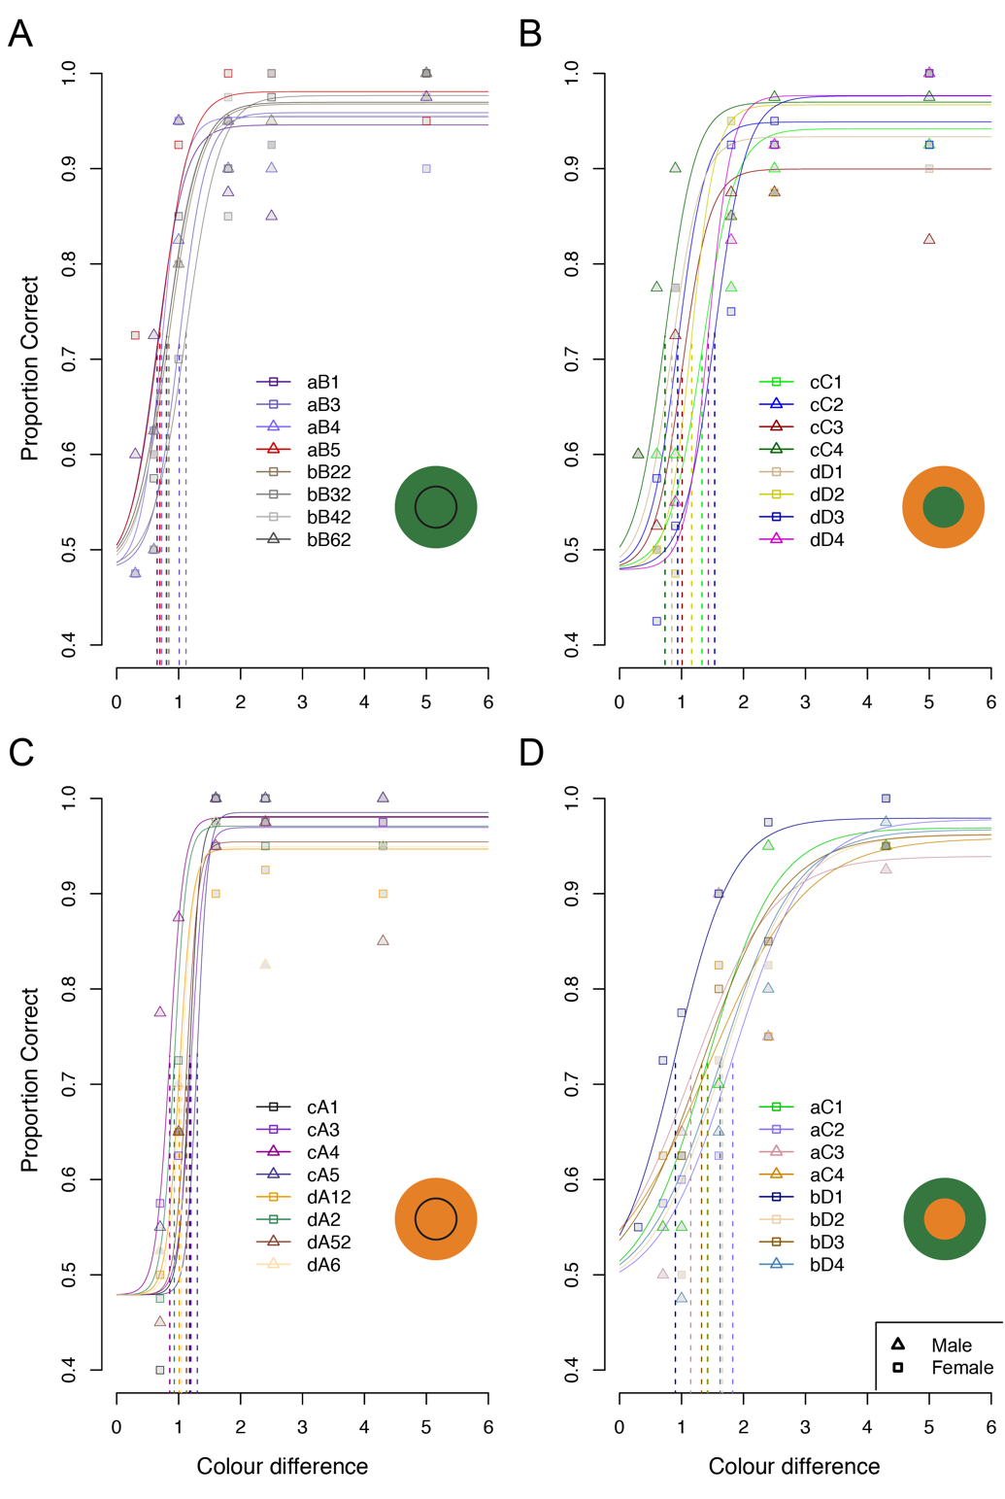

**Figure S3. Bayesian model predictions for performance as a function of colour difference for each individual chicken.** Each solid line indicates the mean estimate of the psychometric curve for an individual chicken. Colour codes in the legend correspond to each of the chickens that participated in an experiment. The names shown are a combination of a lower case letter indicating the batch from which the individuals were drawn and an upper case letter and number that was the chicken’s identifier during the experiment. Mean thresholds (mean ±SD: 1.11 ±0.31), threshold-widths (mean ±SD: 1.29 ±0.73) and lapse rates (mean ±SD: 0.038 ±0.018) varied widely for different individuals, even within experiments.

**Figure S4. Posterior predictive checks for the Bayesian inference model.** Two graphical checks were performed to compare the observed data to simulated data derived from model predictions – each simulating 100 times from the posterior predictive distribution. (A) bar-chart indicating the number of observed trials with correct (1) or incorrect (0) choices, divvied up by whether the stimulus and background colour types were the same (Same) or differed (Different). (B) rootogram showing the square roots of the total number of observed data for which the choice during a trial was correct (1) or incorrect (0), as well as a line indicating the expected values. A black dot and red bar indicate the location of simulated data (y rep) and its error. For both graphical summaries, the simulated and observed counts closely align, which supports the validity of the model.